Operating system

Définition :

* Exploits the hardware resources of one or more processors ;
* Provides a set of services to system users ;
* Manages secondary memory and I/O devices.

Computer basic elements :

* Processor ;
* Main memory ;
* I/O Modules ;
* System bus.

Processor :

* Controls operation, performs data processing ;
* Two internal register :
  + Memory address register (MAR );
  + Memory buffer register (MBR) .
* I/O address register ;
* I/O buffer register .

Main memory :

Volatile, data is typically lost when the power is removed. Referred to as real memory or primary memory.

# I/O Modules

Moves data between the computer and the external environnement such as :

* Storage ( ex : hard drive) ;
* Communications ;
* Terminals.

Specified by an I/O Address Register.

System bus :

Communication among processors, main memory and I/O modules.

Processor Registers :

Faster and smaller than main memory.

Exemple of types of registers which are available are : data, address, condition code registers.

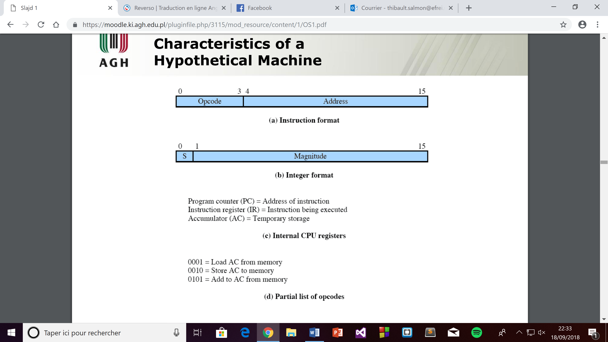

# Memory hierarchy :

* Faster access time => greater cost per bit ;
* Greater capacity => smaller cost per bit ;
* Greater capacity => slower acces speed.

Secondary memory :

* Auxiliairy memory ;
* External ;
* Nonvalatile ;
* Used to store program and data files.